BestBay
Created on 9/19/2011
Table of Contents
SketchFlow Map 2
Navigation Screens 2
(Visitor) Homepage 3
(Buyer / Seller) Item Details 4
(Buyer / Seller) Search Results 5
(Buyer) Login Proile 6
(Seller) Login Proile 7
(Seller) Sell Item 8
(Visitor) Item Details 9
(Visitor) Registration 10
(Visitor) Search Results 11
Figures
Figure 1: SketchFlow Map 1
Figure 2: (Visitor) Homepage 2
Figure 3: (Buyer / Seller) Item Details 3
Figure 4: (Buyer / Seller) Search Results 4
Figure 5: (Buyer) Login Proile 5
Figure 6: (Seller) Login Proile 6
Figure 7: (Seller) Sell Item 7
Figure 8: (Visitor) Item Details 8
Figure 9: (Visitor) Registration 9
Figure 10: (Visitor) Search Results 10

SketchFlow Map
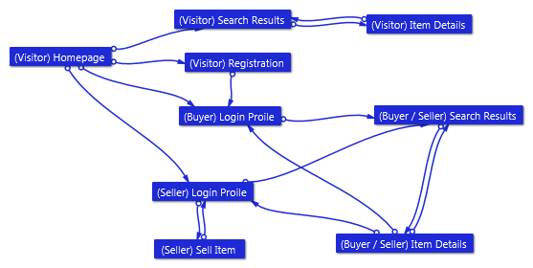
Figure 1: SketchFlow Map

Navigation Screens

(Visitor) Homepage
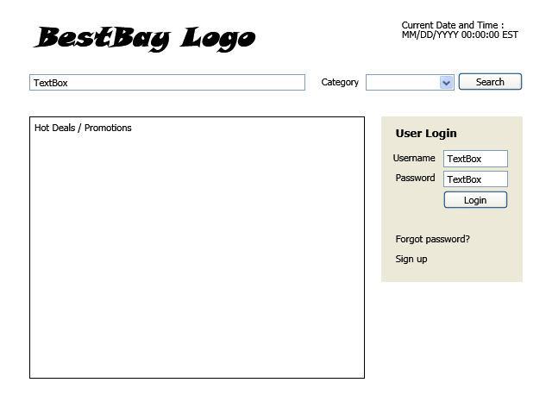
Figure 2: (Visitor) Homepage

(Buyer / Seller) Item Details
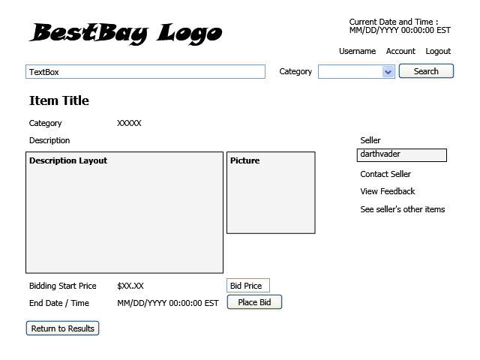
Figure 3: (Buyer / Seller) Item Details

(Buyer / Seller) Search Results
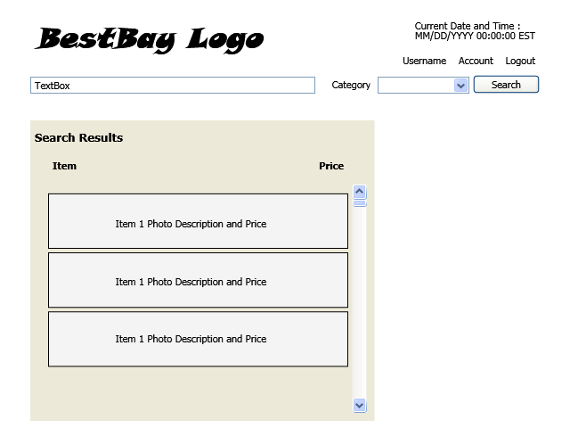
Figure 4: (Buyer / Seller) Search Results

(Buyer) Login Proile
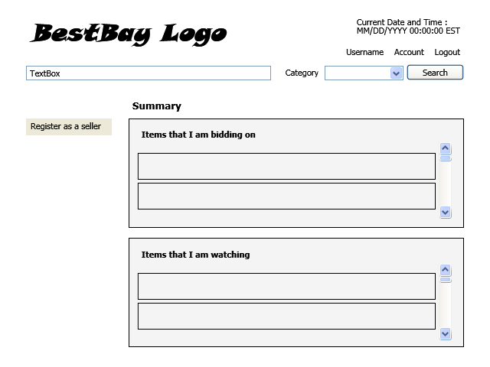
Figure 5: (Buyer) Login Proile

(Seller) Login Proile
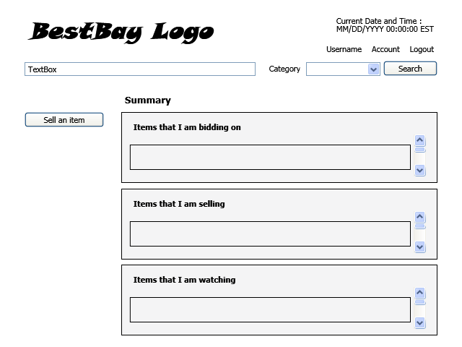
Figure 6: (Seller) Login Proile

(Seller) Sell Item
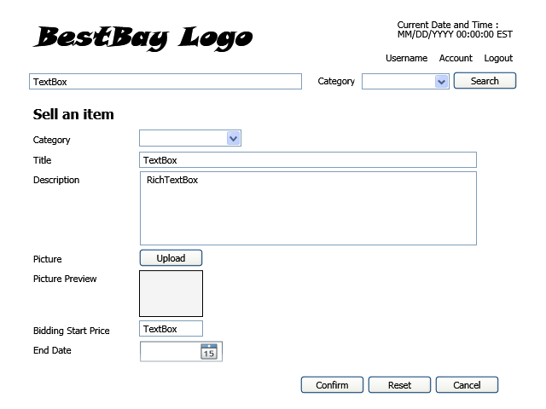
Figure 7: (Seller) Sell Item

(Visitor) Item Details
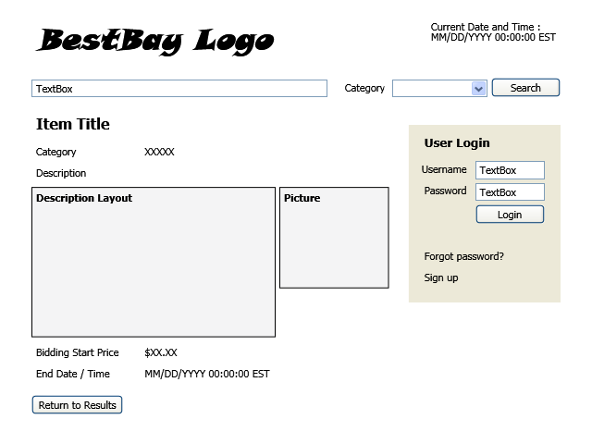
Figure 8: (Visitor) Item Details

(Visitor) Registration
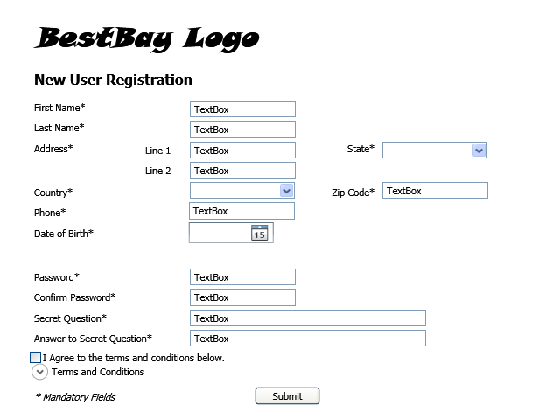
Figure 9: (Visitor) Registration

(Visitor) Search Results
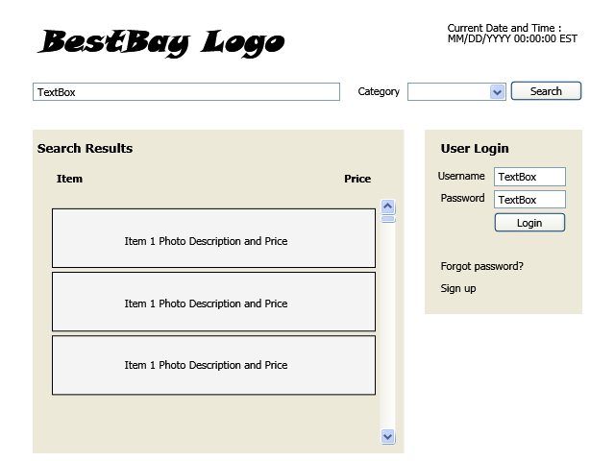
Figure 10: (Visitor) Search Results

